
VIVERE DISCE, COGITA MORI - “ DIE TO LIVE OR LIVE TO DIE. ”

____________________  CHARACTER NAME ____________________  INWARD CHARACTER TYPE  ____________________  OUTWARD CHARACTER TYPE  ____________________  TOOL & CURRENCY  ____________________  ____________________  PAST OCCUPATIONS  ____________________  EXPERIENCE POINTS & HUBRIS SCORE*  (For hubris score your character from 1 to 10)  * Hubris: A dangerous mix of excessive pride and foolish overconfidence. | RESOLVE  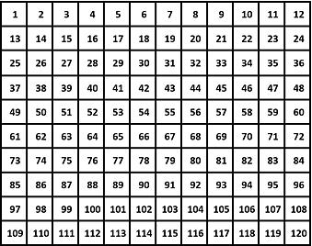  If Challenge roll was 1 thru 6 shade 1 point, 7 thru 11 shade 2 points, 12 thru 15 shade 3 points and 16 thru 18 shade 4 points.  (Circle threshold point then shade boxes until reached.)
FERVOR |  | GRIT
PRINCIPLE OF THOUGHT |  | MENTAL | 
RULE OF FORCE |  | PHYSICAL
NATURE OF BEING |  | EMOTIONAL
WILL OF SPIRIT |  | SPIRITUAL
LAW OF RELATION |  | ENVIRONMENTAL
UNITY OF LIFE |  | INTERPERSONAL

Circle dice for number assigned. |  | Shade boxes in Resolve when Challenge roll exceeds the target Grit category. If challenge roll does not exceed target Grit category than leave Resolve as is.
---------------------------------------------------------------------------------------------------------------------------------------------
---------------------------------------------------------------------------------------------------------------------------------------------
---------------------------------------------------------------------------------------------------------------------------------------------
---------------------------------------------------------------------------------------------------------------------------------------------
---------------------------------------------------------------------------------------------------------------------------------------------
---------------------------------------------------------------------------------------------------------------------------------------------

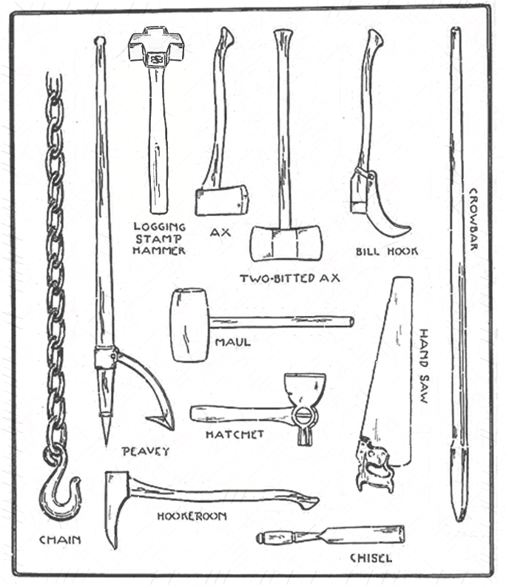
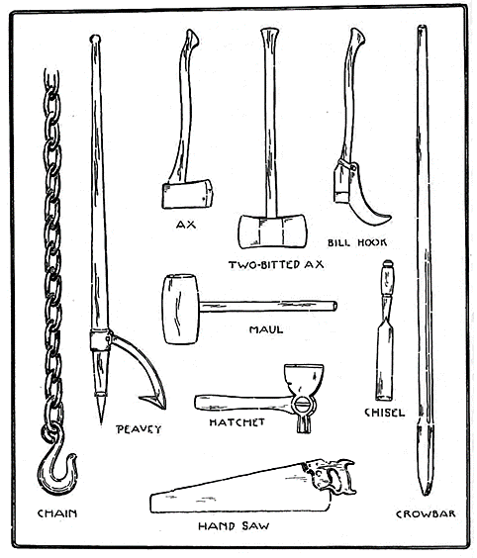
YOUR TOOL

Choose one.

LOGGING CHAIN: Used to hoist logs on to sleds.

PEAVEY: During the spring used to help drive logs down river and break jams.

AX: Used to fell trees.

TWO-BITTED AX: Used to fell trees and in clearing paths through forests (swamping).

BILL HOOK: Used to cut small shrubs and branches.

MAUL: Heavy wooden mallet used to drive wedges or for striking.

CHISEL: Used for cutting or splitting wood.

CROWBAR: Used as a lever to force apart heavy objects.

HAND SAW: Used to cut wood and trim off thick branches.

LOGGING STAMP HAMMER: Used for making marks on logs for the purposes of identification and to safeguard from theft by rival logging companies.

HOOKEROON: Used as a lever to turn over logs.

PICKEROON: Resembling the hookeroon, excepting for a narrower, more pointed head. The point is driven into a log or cord of wood so it can be moved. It saves the logger from stooping over to do so.

SURVIVAL SKILLS

Roll two dice and circle three of your character’s survival skills. If playing as self, choose those that best reflect your own. Storyteller must approve choices if playing as self (order dice from lowest to highest).


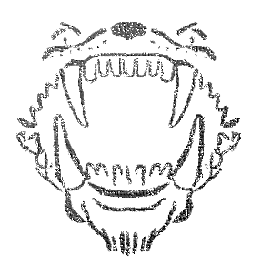

⚀⚀ Proper Hygiene | ⚁⚂ Shelter Building | ⚂⚅ Literacy
⚀⚁ Fishing | ⚁⚃ Cooking | ⚃⚃ Hunting
⚀⚂ First Aid | ⚁⚄ Sewing | ⚃⚄ Shelter Building
⚀⚃ Fire Starting | ⚁⚅ Water Sanitation | ⚃⚅ Cleaning
⚀⚄ Hunting | ⚂⚂ Proper Hygiene | ⚄⚄ Fire Starting
⚀⚅ Literacy | ⚂⚃ Tying Knots | ⚄⚅ First Aid
⚁⚁ Cooking | ⚂⚄ Fishing | ⚅⚅ Water Sanitation
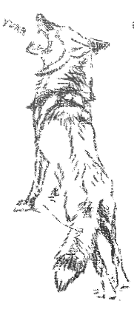
TRAGIC FLAW ( H A M A R T I A)

Roll two dice and circle your character’s tragic flaw or if playing as self select one that best reflects your own. Storyteller must approve choice if playing as self (order dice from lowest to highest).

⚀⚀ You let a small detail, good or bad, determine your view on something.
⚀⚁ You hang on to things when you’ve put a lot of time or effort into them.
⚀⚂ The first thing you think of determines your entire view on something.
⚀⚃ You assume everyone knows what you know.
⚀⚄ You prefer ideas even if false if they agree with how you already think.
⚀⚅ Knowing more about anything makes you less sure about everything.
⚁⚁ You defend ideas, true or false, because they agree with your own view.
⚁⚂ You credit circumstances for your failures but yourself for success.
⚁⚃ The more your ideas are opposed the more strongly you believe in them.
⚁⚄ You often do the opposite of what you are told.
⚃⚄ If an idea, good or bad, is popular you tend to go along with it.
⚁⚅ You over anticipate the negative possibilities of an action.
⚂⚂ You think the past was perfect and the present and future deeply flawed.
⚂⚃ You think people notice and judge everything you say or do.
⚂⚄ You see others’ faults as a result of their character but yours as a matter of circumstance.
⚂⚅ Whether you like someone shapes all opinions you have about him or her.
⚃⚃ You over anticipate the positive possibilities of an action.
⚃⚄ You judge something on how it is presented not on how it actually is.
⚃⚅ Since you like the idea of justice, you assume it exists for everyone.
⚄⚄ You unjustly prefer those who are like you or are part of your group.
⚄⚅ You believe a medicine or treatment works even if it does nothing.
⚅⚅ You wait for others to act in the event of an emergency.

BIGGEST FEAR

Roll two dice and circle your character’s biggest fear or if playing as self choose one that best reflects your own. Storyteller must approve choice if playing as self (order dice from lowest to highest).

⚀⚀ Fire | ⚁⚂ Frogs | ⚂⚅ Ghosts
⚀⚁ Being Buried Alive | ⚁⚃ Being Alone | ⚃⚃ Wolves
⚀⚂ Thunder/Lightning | ⚁⚄ Rats | ⚃⚄ Returning Home
⚀⚃ Closed Spaces | ⚁⚅ Snakes | ⚃⚅ Blood
⚀⚄ Water/Drowning | ⚂⚂ Bridges | ⚄⚄ Tunnels/Caverns
⚀⚅ Spiders | ⚂⚃ Heights | ⚄⚅ Strangers
⚁⚁ Cliffs | ⚂⚄ Crowded Places | ⚅⚅ Being Lost

SIDE SKETCHES FROM ROLF IN THE WOODS BY ERNEST THOMPSON SETON

PAST OCCUPATIONS

In a past life maybe you were a cowboy or even an explorer, but what of your character’s less exciting roles? These will, likewise, determine what other skills or knowledge player’s characters are likely to have. Roll three dice three times and circle your character’s other past jobs (order dice from lowest to highest).

⚀⚀⚀ YOUR CHOICE | ⚀⚄⚄ Cabinetmaker ⁸ | ⚂⚂⚂ YOUR CHOICE
⚀⚀⚁ Stable Keeper | ⚀⚄⚅ Physician | ⚂⚂⚃ Farrier ¹⁵
⚀⚀⚂ Sharecropper | ⚀⚅⚅ Barber | ⚂⚂⚄ Mechanic
⚀⚀⚃ Gunsmith | ⚁⚁⚁ YOUR CHOICE | ⚂⚂⚅ Miller
⚀⚀⚄ Lineman ¹ | ⚁⚁⚂ Hatter | ⚂⚃⚃ Chimney Sweep
⚀⚀⚅ Coppersmith | ⚁⚁⚃ Wheelwright ⁹ | ⚂⚃⚄ Shoemaker
⚀⚁⚁ Ropemaker | ⚁⚁⚄ Rat Catcher | ⚂⚃⚅ Printer
⚀⚁⚂ Peddler ² | ⚁⚁⚅ Tailor | ⚂⚄⚄ Street-Lamp Lighter
⚀⚁⚃ Porter ³ | ⚁⚂⚂ Mason | ⚂⚄⚅ Sadler ¹⁶
⚀⚁⚄ Stationer ⁴ | ⚁⚂⚃ Carter ¹⁰ | ⚂⚅⚅ Cutler ¹⁷
⚀⚁⚅ Tobacconist ⁵ | ⚁⚂⚄ Clerk | 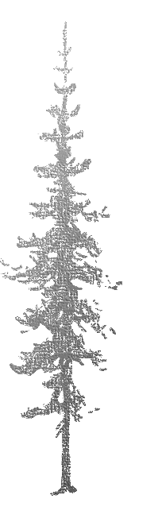  ⚃⚃⚃ YOUR CHOICE
⚀⚂⚂ Baker | ⚁⚂⚅ Tallowmaker ¹¹ | ⚃⚃⚄ Whitesmith ¹⁸
⚀⚂⚃ Distiller | ⚁⚃⚃ Coachman ¹² | ⚃⚃⚅ Blacksmith/Dentist
⚀⚂⚄ Bottler ⁶ | ⚁⚃⚄ Train Conductor | ⚃⚄⚄ Miner
⚀⚂⚅ Fur Trader | ⚀⚃⚅ Constable | ⚃⚄⚅ Laborer
⚀⚃⚃ Butcher | ⚁⚄⚄ Copyist ¹³ | ⚃⚅⚅ Finder ¹⁹
⚀⚃⚄ Leather Worker | ⚁⚄⚅ Gold/Silversmith | ⚄⚄⚄ YOUR CHOICE
⚀⚃⚅ Cooper ⁷ | ⚁⚅⚅ Druggist ¹⁴ | ⚄⚄⚅ Knocker-Up ²⁰
1. LINEMAN: A telegraph repairman and railway examiner.  2. PEDDLER: A traveling trader.  3. PORTER: A doorman or luggage carrier.  4. STATIONER: A bookdealer. |  | ⚄⚅⚅ Quarryman ²¹  ⚅⚅⚅ YOUR CHOICE
5. TOBACCONIST: A Tobacco retailer.  6. BOTTLER: A person who bottles beverages cider, wine, etc.  7. COOPER: A barrel maker.  8. CABINETMAKER: A furniture maker and repairman.  9. WHEELWRIGHT: A maker of wheels and carts.  10. CARTER: A cart pusher.  11. TALLOWMAKER: A person who works in animal fat to make candles and soap.  12. COACHMAN: A carriage or coach driver.  13. COPYIST: A written transcriptionist.  14. DRUGGIST: A pharmacist.  15. FARRIER: A person who shoes horses and acts as a veterinarian. |  | 16. SADLER: A person who makes saddles.  17. CUTLER: A person who sell, repairs and makes scissors and knifes.  18. WHITESMITH: A worker in tin, steel or iron who then polishes crafts to mimic silver.  19. FINDER: A person who is paid to locate missing items.  20. KNOCKER-UP: A person who worked before alarm clocks, by banging on doors or windows with a long pole to wake people up.  21. QUARRYMAN: A person who extracts stone from a quarry.

TO BE OR NOT TO BE?
Write down on the next page, or on a sheet of scratch paper, the names of each of your fellow players’ characters and roll a die to see how your character feels about them:
⚀ STRONGLY FAVOR … ⚁ FAVOR … ⚂ JUST OKAY WITH
⚃ ANNOYED WITH … ⚄ DISLIKE … ⚅ STRONGLY DISLIKE
Discuss with your fellow players to create a backstory on what happened. Why does each character feel the way they do about the other? Did something happen at camp or was it during a past job? Refer to each one’s character sheets for ideas.

SUGGESTED IDEAS FOR TACTICS/ACTIONS

PRINCIPLE OF THOUGHT  Tactics intended to bewilder opponent into retreat.  1.) Misdirect  2.) Feint  3.) Corner  4.) Follow in Zigzag  5.) Attack Around the Enemy  6.) False Retreat  7.) Do the Unexpected/Unusual  8.) Play Dead/Act Injured  9.) Thought Transference  10.) Camouflage | NATURE OF BEING  Tactics intended to intimidate opponent into retreat.  1.) Battle Cry  2.) Stare Down  3.) Statue Stance  4.) Charge and Stand Ground  5.) Twirl or Swing Weapon  6.) Beat Chest  7.) Clank Items/Create Sparks  8.) Circle Opponent  9.) Laugh at Danger  10.) Stomp Ground | WILL OF SPIRIT  Tactics intended to compelled opponent into retreat.  1.) Prayer  2.) Sing Hymn  3.) Hold Relic  4.) Silent Mediation  5.) Chant  6.) Bless  7.) Recite Verse  8.) Exorcise  9.) Astral Projection  10.) Cast Light into Darkness
RULE OF FORCE  Tactics intended to injure opponent into submission.  1.) Bare-Knuckle Punch  2.) Dropkick  3.) Choke Hold  4.) Smack/Chop  5.) Strike with Weapon  6.) Grapple  7.) Bodyslam  8.) Bite and Pull Hair  9.) Human Cannonball  10.) Gouge with Thumbnail | LAW OF RELATION  Tactics intended to exhaust opponent into submission.  1.) Throw/Shoot Projectile  2.) Dash  3.) Jump  4.) Roll  5.) Climb  6.) Backflip  7.) Cartwheel  8.) Wall Flip  9.) Somersault  10.) Spin | UNITY OF LIFE  Tactics intended to appeal an opponent into submission.  1.) Discuss / Animal Call  2.) Make Offering  3.) Play Instrument / Sing  4.) Persuade / Lure  5.) Mirror Body Language  6.) Wave Handkerchief  7.) Show Palms Forward  8.) Beg / Kneel  9.) Mesmeric Trance  10.) Hypnosis
B I B L I O G R A P H Y

CWF, “Occupations and Trades of the Eighteenth Century,” The Colonial Williamsburg Foundation, 2018,
http://www.history.org/history/teaching/trades.cfm.
Gilbert, Stephanie P. “Definitions of Common Nineteenth-Century Occupations,” Harrisburg's Old 8th Ward, 2005,
http://www.old8thward.com/occupations.htm.
Noyes, William. Handwork in Wood. New York: Columbia University, 1910. https://archive.org/details/handworkinwood00noyerich.
Richardson, Jesse and Flip. “24 Cognitive Biases.” The School of Thought, 2018, https://www.yourbias.is/.
Seton, Ernest T. Rolf in the Woods. New York: Doubleday Page and Company, 1911.

