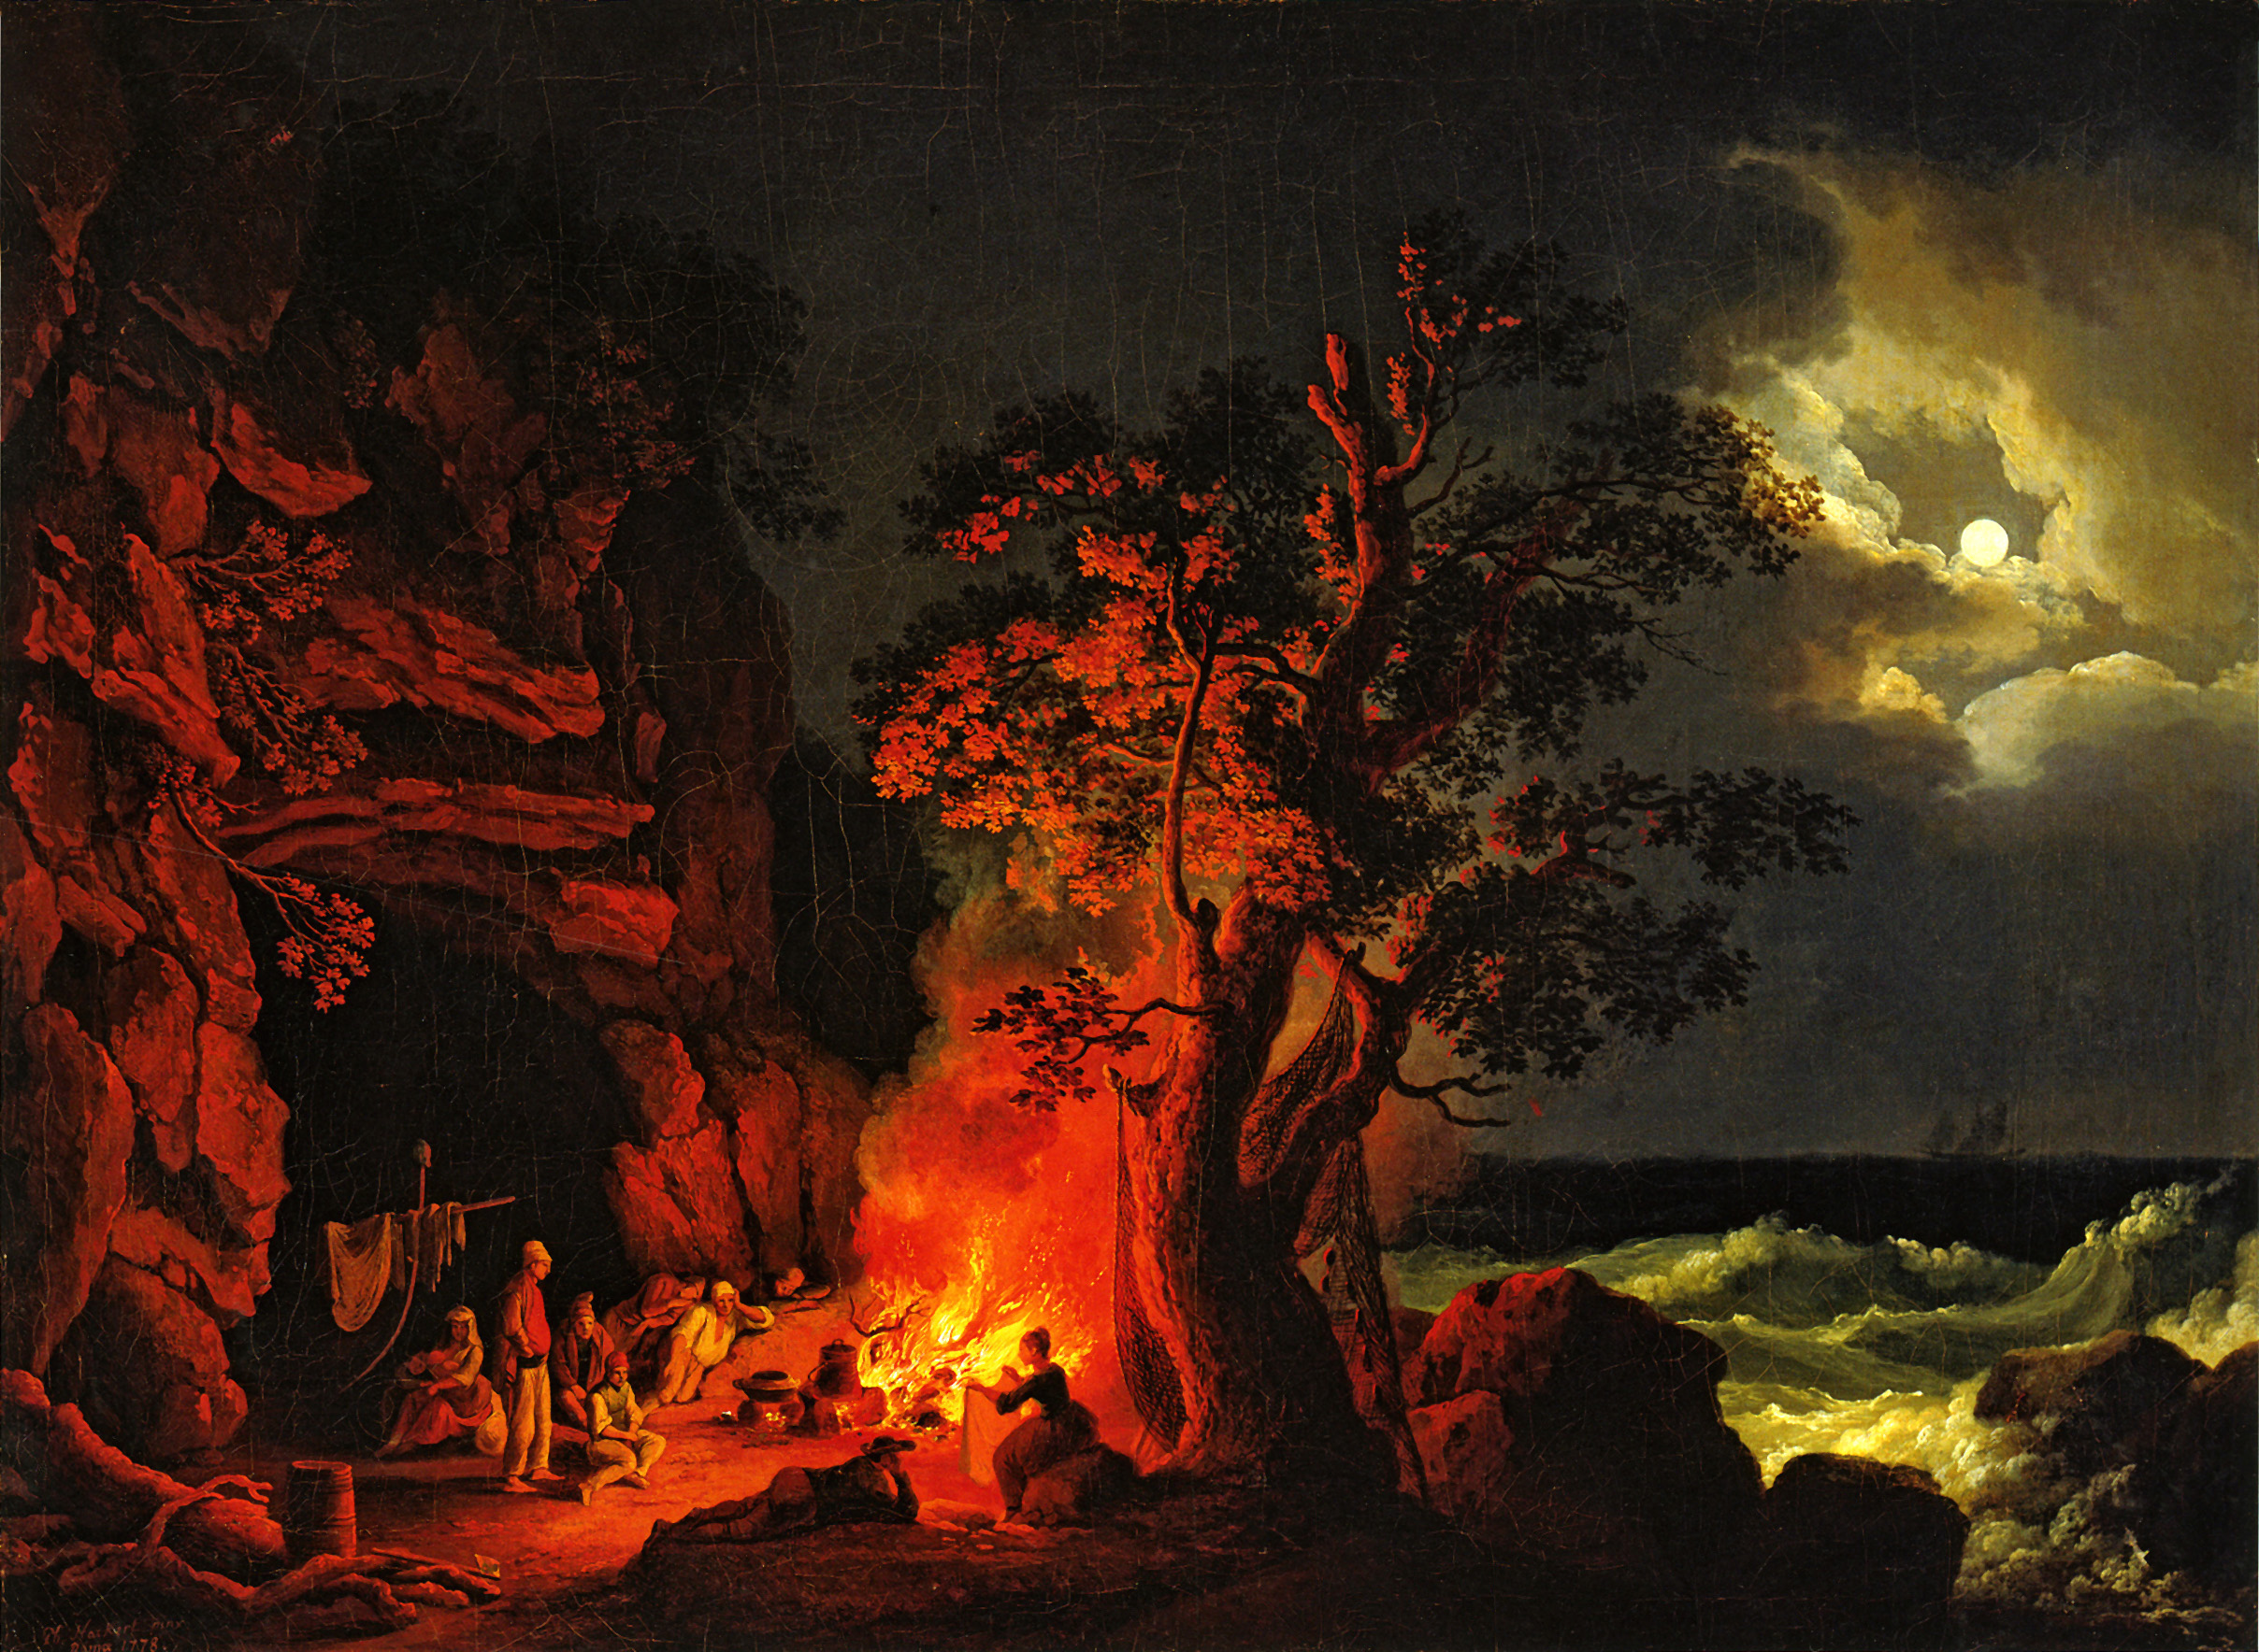




™

Cover Art: Jacob Philipp Hackert, Fischerfamilie am nächtlichen Lagerfeuer mit aufgewühltem Meer (1778)
A M A K E Y O U R O W N A D V E N T U R E G A M E



PROLOGUE
*
Before each game the Prologue sets the mood.
You can use this or make up your own.

The thing about old storytellers is that magic is not part of their story. Magic is what happens behind it. How else could one begin to describe the way they entrance us or transport us to forgotten, faraway lands. The old storytellers were masters of their art. They were lively yet humble, humorous but wise, above all they were shepherds to and equals among their audience.

They were the ones who would tell you about ships that could fly and impossible feats of strength; of thrilling adventure, fearsome creatures and especially Paul Bunyan— of course, you have all heard of Paul.

Paul was the greatest lumberjack who ever lived. Stories tell of a brawling, fearsome giant, tougher than nails. Eight feet tall he stood with a stride of eight feet. Celebrated everywhere was he for his great labors and matchless crew.

This— this is one those stories.

It is an account of faraway lands, of fearsome beasts, of ships that can fly, it is a tale of that old type of storyteller and the time of Paul Bunyan.


INTRODUCTION
Before each game the Introduction sets the setting.
You can use this or make up your own.

YOU ARE A LUMBERJACK, a member of that both equally respected and despised fraternity of woodchoppers and storytellers. Your hard-working, hard-drinking and hard-fighting exploits are the talk of every city, port and town. You dwell within a forgotten North American republic, a member of Paul Bunyan’s logging camp. You have been laboring away all winter, far removed from the signs and symptoms of civilization. Yet, during your stay your fellow “jacks” sense that curious forces are afoot. Rumors persist of a mysterious stranger encountered in the forest and the unseen influence of a strange, invisible world. But you scoff at such rumors, what are they to you? Camp talk is all. Tall tales, windies that loggers spin in bunkhouses after the day's work is done. But, as work pushes on, the truth of such stories grow beyond doubt. Bizarre accident after another has steadily disrupted the camp’s work. As members of an ancient and secret society, the “old man” sends for you and your comrades to search the wilderness and ask around town to settle the matter. You all might not be the most skilled nor the best equipped, quite likely rather the most troublesome or expendable. Nevertheless, in attitude and inventiveness you may very well surprise yourselves. So, with leave of your duties, your band ventures off into the uncharted wilderness. Perhaps, never to be heard from again.
* PROLOGUE takes inspiration from the writings of folklorists
K. Bernice Stewart, Homer A. Watt, and Charles E. Brown.

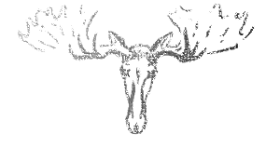

PLAYING A STORY

“Be as a lamp unto them that walk in darkness, a joy to the sorrowful, a sea for the thirsty, a haven for the distressed, an upholder and defender of the victim of oppression.”

– Bahá’u’lláh, Bahá’í Faith


First and foremost, the point of About Old Storytellers or a Game of Campfire Lore (AOS) is to have FUN and not to stress over each little detail. AOS is a story that one plays rather than only tells or hears. Instead of choosing an adventure, AOS allows participants to make their own adventure. The game does this through a system of simple rules and the power of storytelling.

Think of AOS like a long dream that all the players are having at once. Only when thinking back to our dreams do we realize they are impossible. For while we are dreaming, there is little to separate fantasy from reality. This is the goal of AOS, to experience something that feels real in a fantasy, like in a dream. In this dream, that is story, each player is a completely different person, or character, if not his or herself. This character lives in a forgotten land where fantastic things can and do happen. At the same time, a narrator, or Storyteller, uses a Story Guide (SG) to tell the players what is happening in the story. The Storyteller creates the story. He or she describes what the characters see, hear and feel. The Storyteller also voices other characters they may meet. In AOS, players narrate their characters’ actions in detail and dialog out loud. The Storyteller directs the story based off their responses and a lot of imagination.

Sometimes the story is about adventure and fighting. Other times, it is about mystery and gathering information. In either case, the goal in AOS is not always to win but to have fun. In AOS, unlike other games, it can be more fun to lose or make the wrong choices than the right ones. As well, while rules are often useful, it is story that always takes precedence in AOS not rules. The Storyteller exercises full discretion on whether to bend a rule to fit the story.

In AOS, players assume the role of a band of lumberjacks in the time of Paul Bunyan. Players bring their characters to life through improvisation. Players may also use any talents they may have to enhance the experience. This adventure differs from video games or movies in that it is only limited by one’s imagination. Picture a book that changes the story every time you pick it up, AOS is that book and your adventure is that story. Players play AOS in the dark under minimal lighting. The Storyteller starts each game by reciting or creating a prologue (to set the mood) and introduction (to set the setting).

AOS is like other strategy-based games, but one need not be an expert to play. The instructions herein are short and to the point. So, just relax and read through these easy instructions. Your adventure will begin in no time. The following offers, if you will, the essential “ingredients.” It rests on the Storyteller and the players to come up with the basic “recipe.”
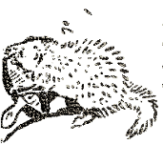

Side sketches from Rolf in the Woods, by Ernest Thompson Seton


THE BASICS

To play you will need these instructions, the About Old Storyteller’s Story Guide + Character Sheets, scratch paper and dice (D6). As well don’t forget a lantern, Storyteller and a heap of hearty participants.

❏ Character: A character is a fictional person that a player acts out in AOS. Think, how is this character similar or different from you? Who are they exactly? What is their story? How do they sound? What would they do that you would not?

❏ Prompts are clues that help build the plot and move the story forward. The Storyteller creates prompts. Prompts consist of things that lead characters to the bigger story (i.e. hearing a call for help or spotting strange tracks).

❏ Actions are choices that players make in response to prompts. An action is usually always successful if it is very easy (like knocking on a door). It is usually always unsuccessful if too hard (like moving a mountain). Yet, between the two, the Storyteller MAY OR MAY NOT have players roll dice to determine the outcome. The Storyteller thinks up a mystery number (between 1 and 18) and asks the player to roll. Every action corresponds with one of the player’s character's Fervor types (SEE Fervor). These specify up to how many dice a player can roll. If the player’s roll exceeds the number his or her action is successful, if not then it is not. It is fully up to the Storyteller whether to use dice for determining actions.

❏ Challenges: Yet, when actions lead to life-or-death situations prompts become Challenges. Challenges can include creatures, machines or other hazards. To select a Challenge the Storyteller rolls three dice and places them from lowest to highest. He or she looks up the Challenge that matches that dice combination in the SG. The Storyteller decides at what point characters must counter a Challenge through Engagement (SEE Next Page). If that point is not reached the Challenge passes through and does no harm.

❏ Tactics are like actions but used by players to meet Challenges. The Ten Rules of Engagement determines the outcome of tactics. Each Character Sheet has a list of suggested ideas for tactics.

❏ Fervor are categories that tactics fall under. Each Fervor has its own name, color and symbol. If tactics were numbers on playing cards think of Fervor like the different suits.

❏ Unique Values are central to AOS. If a player or the Storyteller rolls any of the same values (doubles, triples, etc.) on any dice, these dice are not counted. For only unique values (any value appearing on only one die) count towards a roll’s total.

❏ Character Sheets & Challenge Pages: Each character and Challenge has a guide for reference. For players, these are their Character Sheets that they fill out before playing. For the Storyteller, these are Challenge pages that are already filled out in the SG.

TEN RULES OF ENGAGEMENT

In Engagement players work to defeat or overcome a Challenge.

❏ RULE 1: Each character sheet and Challenge page has two matching sets of six totals each. The first set, called Fervor, represents the different methods of scoring. Each total in the Fervor set matches with another in the second set, called Grit. Fervor lists the number of dice that a player can roll at once. Grit lists the value a roll must exceed to be effective. Resolve is a third category that determines when a character or Challenge must exit the game.


❏ RULE 2: Each turn consists of a roll by a player followed by a counter roll by the Storyteller. At the start of the Challenge, each player rolls one die. The player with the highest value rolls first against the Challenge. The player with the lowest value rolls last. For same values, roll again to break any ties.

❏ RULE 3: Players score by describing how their character performs a certain tactic. The tactic used either comes from their imagination or character sheet. He or she then ROLLS UP TO OR FEWER THAN the number of dice listed for the Fervor type best fitted to it. The player tries to exceed the Challenge's matching Grit type. If this happens points get taken away from the Challenge’s Resolve. The Challenge page specifies how many points get taken away.

❏ RULE 5: Often a player’s Fervor roll does not exceed the value of the Challenge's matching Grit. If so, the Storyteller declares the tactic a “miss” or “ineffective” and does not take away points.

❏ RULE 6: After a player rolls, the Storyteller counters. The Storyteller selects a Fervor type from the Challenge and rolls. This time, the Storyteller tries to exceed the player's matching Grit type. The cycle then repeats itself, this time with the role of the player and Storyteller reversed.

❏ RULE 7: If a player or the Storyteller roll the same value on two or more dice, these dice are not counted. Only the dice with unique values are totaled.

❏ RULE 8: The object of Engagement is for the players to defeat or overcome a Challenge. As well, characters may simply be trying to survive long enough for a Challenge to pass through. The first method is for the players to exhaust a Challenge's Resolve. This works well in most situations. But what if their characters discover a fatal weakness or bold solution? It is a good practice for the Storyteller to reward players for creative storytelling. The Storyteller can always declare a Challenge over if it would be best for the story.

❏ RULE 9: A certain Fervor type should prevail according to a Challenge’s page. Yet, the right choice of tactic can make or break this. A tactic must make sense for story purposes. If not, the Storyteller can declare it, “ineffective,” regardless of all else. The Storyteller exercises full discretion on tactical appropriateness. That is whether a tactic is playable at any point.

❏ RULE 10: When a character loses all their Resolve, their Resolve is “broken.” Their character is then removed from the game. This is conveyed in the story as the character falling into a trance, disappearing into the woods, losing their mind, falling into a coma, becoming petrified, etc.

FERVOR: FIRE THAT BURNS FROM WITHIN


All created things are twofold in nature. Besides an outward or superficial nature, everything has yet another inner, truer nature. This higher essence comes to us by Fervor. Fervor is the outward sign of the “innermost within.” It is the unseen spirit fire that pushes us beyond material limitations. It is the tapestry of true existence from within all things animate and inanimate. Such is beyond our senses and past the understanding of little human creatures. Yet, behind these secrets lie a hidden power. This mystery is what enables many a folk hero to perform all sorts of superhuman feats. Be yet warned. Fervor itself does not equal power. It is, as even is nature— a force to be reckoned with. Water and heat can be used to produce steam. But, so might water flood, heat burn, and steam explode if not wielded properly. Only if channeled correctly will it work to your advantage.

❏ PRINCIPLE OF THOUGHT (Mental): The Principle of Thought imbues one with cunning, insight and the ability to make decisive choices. It allows one to bewilder an opponent into retreat and is useful in overcoming illusions. Still it is, alas, only truly effective against logical beings.

❏ RULE OF FORCE (Physical): The Rule of Force grants endurance in the face of brute strength. It is best in a brawl but only against adversaries that can be felled with an axe, gouged with a thumbnail or who cast a shadow. With it one may strike opponents, injuring them until they can fight no more.

❏ NATURE OF BEING (Emotional): The Nature of Being imbues one with the ability to face their fears and to keep going when others would steadily retreat. It is especially useful in detecting if something is amiss. It affords protection from such creatures that feed upon terror and is often best employed to intimidate opponents into a steady retreat.

❏ WILL OF SPIRIT (Spiritual): Evil may be ancient, but it is not eternal. The Will of Spirit provides ample protection from it. For it grants one with guidance and hope in the face of death.

❏ LAW OF RELATION (Environmental): The Law of Relation directs the relationship between one and their surroundings. It is a vital for accuracy, stamina, balance, swiftness and survival. It is useful in tiring an opponent into submission but just in those foes who are not boundless in energy.

❏ UNITY OF LIFE (Interpersonal): A quality radiating the Unity of Life governs the bonds between oneself and other living beings. It appeals to those who can be appeal to. It proves a decisive advantage in forming alliances, squaring off with wildlife or for diplomatic measures.

❏ CELESTIAL HARMONY (Astral): As the heavenly spheres perfectly align above, their music empowers you. By rolling all counting numbers (values within one digit of another), on three or more dice, values are now doubled.
❏ ORDER OF THE UNIVERSE (Ethereal): Except where otherwise noted, rolling a value of eighteen (⚅-⚄-⚃-⚂) permits any Challenge to be immediately defeated.

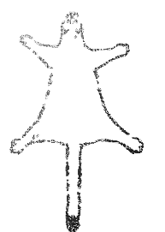

OUTWARD CHARACTER

Everyone who works in a logging camp is a lumberjack or more precisely a logger. However, each logger plays a different role in lumbering operations. Each player must select a trade from below.

❏ SWAMPER (+ , - ): The swamper is a general utility man and helps out the other loggers in many ways. Most often, the swamper assists in “swamping” or cutting a skidway through the forest. As well, the swamper clears obstructions that get in the way of work.

❏ CHOPPER (+ , - ); The chopper generally works by himself and goes through the woods selecting trees to fell. Afterwards, he or she trims and measures the logs for sawyers to cut apart.

❏ SAWYER (+ , - ): Sawyers either singly, or in pairs, follow the choppers and cut the felled trees into saw-logs. The swamper then removes any remaining limbs and drags the log to the side of the skidway with help of an ox.

❏ HOOK-TENDER (+ , - ): The hook-tender oversees getting the logs from the skidway onto a log sled. He or she places the chain around the logs, so they can be hoisted onto sleds. The hook-tender looks out for the safety of others.

❏ SKIDDER (+ , - ): The skidder handles placing the logs up in huge, barn-shaped piles, twenty or thirty feet high, upon large log sleds. This is perhaps the most dangerous job in logging. He or she also keeps the skidway in repair.

❏ TEAMSTER (+ , - ): The teamster drives the log sleds over the iced skidway back and forth to the river. He or she works mostly with oxen, as they are by far the best animals for the woods. The teamster also takes care of and shoes their animals. Two hours before daylight the teamsters care and feed the oxen.

NO “ COWBOYS AND ‘INDIANS’ ” PLEASE: Popular fiction has a strong tendency of portraying the distinction between good and evil as skin deep. This makes for dull storytelling, as players would know instantly who’s friend or foe based on superficial impressions. Not to mention it is plainly disrespectful. It is important to try to prevent this. Before creating a nonplayable character within a demographic, the storyteller should think about his or her perceptions of that group in real life. Is it positive or negative? Does one feel ‘they’ are all alike or not so much? Does one think in terms of “innocent until proven guilty” or “guilty until proven innocent?”

Does one ever confuse not caring if someone is innocent with someone actually being guilty, despite those being two different things? The world is never so black and white, and whether the Storyteller creates a human character who is righteous, wicked or somewhere in between should not be inferred on things like gender, disability, nationality, social class, ethnicity, etc. So, upon fleshing out a nonplayable character roll one die to find out his or her persona from the following: ⚀ Saintly - ⚁ Good Guy - ⚂ If pressured still has your back - ⚃ If pressured will turn on you - ⚄ Bad Guy - ⚅ Wicked

Logging camp occupational descriptions are largely derived from “Among the Woodcutters” SEE BIBLIOGRAPHY



INWARD CHARACTER

Logging is seasonal work and every “jack” has or had another life beyond that of a logger. It is equally important in selecting your double-life outside of camp. Select between the following six:

❏ GUNSLINGER (+ , - ): It matters not if you were a trapper, frontiersman or cowboy, your trailblazing days are never too far behind.

❏ MANHUNTER (+ , - ): Crime and corruption are a constant threat to this young republic, and your sense of duty calls you to put an end to it. Either as a detective, spy or lawman, you never miss your mark.

❏ SWASHBUCKLER (+ , - ): Perhaps, you were rewarded as a privateer before the golden age of piracy ended or maybe applauded as a spirited avenger writing unjust wrongs. Whatever, you can feel the thrill of the fight pulsing in your veins like an old familiar song calling you back.

❏ FUTURIST (+ , - ): You always had a great imagination, so your prowess at things scientific comes as no surprise. Your vision for tomorrow consists in creating mechanical marvels. Your ingenuity will take you far on your journey.

❏ TREASURE HUNTER (+ , - ): Whether searching for priceless relics or discovering a lost city, you thrive on the chance for adventure.

❏ BLOODSTOPPER (+ , - ): With the words of Ezekiel 16:6, “And when I passed by thee, and saw thee wallowing in thy blood, I said unto thee: In thy blood, live; yea, I said unto thee: In thy blood, live,” you can stop bleeding and restore people back to health.
WHO IS PAUL BUNYAN? If you don’t know who Paul Bunyan it is probably better that way. For the original Paul Bunyan of folklore is a very different figure than many suppose today. Back in 1910, J. E. Rockwell, in the nature journal The Outer’s Book, wrote of an eight foot, three-hundred-pound, peerless-smoking logging camp boss who ruled over his subordinates “with an iron hand.” He is a man of great might, resourcefulness, harder than rock, whose voice shook the earth and made his workers jump. Here the rigid Paul Bunyan is accompanied by his logging crew, his cook and a peculiar blue ox. This beast, here nameless, is of enormous proportions. The extraordinary creature, “measured eight ax-handles between the horns” and “hauled all the wood and water for the camp.” Here Paul Bunyan is a goliath rather than a Gulliver in stature. Moreover, while he is one of great strength and expertise, he is also one of very human character. He is short-tempered, rugged as well a heavy drinker, smoker and brawler. He possesses the triumphs and fallbacks definitive of a rugged outdoorsman and is all the more celebrated for it. He is the living epitome of the tough-but-fair idea.

FARWAYER OR LOCAL? Amongst the inhabitants of this forgotten republic people are of two types: locals and farwayers. Locals arrive to this part of the country by conventional methods; however, farwayers arrive by mystical means. Locals come from the contemporary period, while farwayers may be of any era, whether 2018 Paris or even 1989 San Dimas. This transition occurs, usually, after one ignites a fire at an abandon campsite or homestead. Upon doing so, an unnatural-colored flame radiates the area; everything it touches bleeding into different surroundings. Soon, the fire fizzles out and he or she is found to be in a cabin or other unfamiliar locale. Each player must decide to play as a local, farwayer or his/herself (as a farwayer).

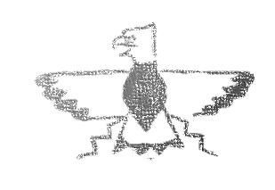
FILLING OUT A CHARACTER SHEET

By default, using a pencil with a good eraser, circle two dice under each of your Fervor types. Now refer to your character selections. Look at the parenthetical symbol after the character title. You will see a plus (+) or a minus (-) beside the symbol. For a plus, add one more die to the Fervor type represented by the symbol listed. Likewise, remove one die for any minuses. Do this based on both your inward and outward character.

After these adjustments are made, roll one die. Add one die to the Fervor type based on the following: 1 , 2 , 3 , 4 , 5 and 6 . If the Fervor type already has four dice roll again. Afterwards, roll once more and this time remove one die for the type represented by the value. If the Fervor type is already at zero, roll again. Four dice is the most one can have for any category. If you end up with zero for any Fervor, you can still use it. But, each time you do, roll one die and flip a coin. If heads it counts against the Challenge, if tails it counts against you.

For your Grit, multiply the number of dice in each of your Fervor types by three. Used each of these six totals to fill in any Grit category of your choosing. These need not correspond with one another. When you are done, roll a die and multiply its value by twenty. Next, circle that number in your Resolve. This marks the fullest extent of your Resolve. Refer to your character sheets to choose from any other selections listed.

Lastly, characters get an advance on their wages. This is based on Outward Character. Wages for characters and non-playable characters are here for storyline purposes. Should a trading post appear in the story, they will serve a more practical use.

Foreman  Teamsters  Hooktenders  Choppers  Sawyers  Skidders | ¤ 100.00  ¤ 90.00  ¤ 70.00  ¤ 65.00  ¤ 60.00  ¤ 55.00 | Swampers  Cooks  Riverdrivers  Raftsmen  Skid Greasers  General Hands |   ¤ 45.00  ¤ 45.00  ¤ 90.00  ¤ 75.00  ¤ 35.00  ¤ 35.00
DON’T BRING THE HAMMER, BE THE HAMMER: Within these rules one will find no comprehensive listing of gear or other such purchasable items to increase a character’s speed or modify their prowess. Such is often the case in classic traditions such as King Arthur’s sword Excalibur, Thor’s hammer Mjölnir, Sun Wukong's staff Ruyi Jingu Bang, Māui’s fish-hook Manaiakalani or even the infamous seven-league boots. The reason, however, is that these stories are not those stories.

What is the name of Paul Bunyan’s axe? What do you call John Henry’s hammer? The answer is nothing, they are just normal tools. For it is not the axe that imbues Paul Bunyan with his skill, likewise nor is the hammer responsible for John Henry’s strength. In these stories, the character is from where the tool draws its power not vice versa. That is this tradition. John Henry is more of the hammer than the hammer is. The tool is merely an extension of himself. That is the simple beauty of tall tales and campfire stories. So, take it from them. Don’t bring the axe, be the axe. Don’t just bring the hammer, be the hammer.


REVIEW

- AOS is a story you can play.
- The Story Guide (SG) is a reference guide that helps the Storyteller create a playable story.
- Prompts are clues that move the story forward.
- Actions are decision that players make in response to prompts.
- Challenges are when actions lead to life-and-death situations. The outcome of a Challenge is determined by the Rules of Engagement.

- The Rules of Engagement are a short list of 10 rules that govern gameplay.
- Storytelling takes precedence over gameplay. The Storyteller determines when and under what circumstances this may happen.
- Tactics are actions that players take in response to Challenges (akin to numbers on playing cards).
- Fervor are the categories that tactics fall under, this forms the basis of strategy in AOS (akin to suits on playing cards).
- Each Fervor type represents the maximum number of dice a player can roll at a given time (each corresponding with a Grit type).
- Each Grit type represents the minimum value needed to remove points from a Challenge’s or player’s Resolve (each corresponding with a Fervor type).
- Resolve determines when a player or Challenge must exit the story.
- Engagement is the process where players use tactics to defeat Challenges.
- Any dice with the same values as other dice (doubles, triples, quadruples, etc.) are disregarded in a rolls’ total. This simulates risk in AOS.
- Character Sheets are quick reference guides to everything there is to know about a player's outward and inward character.

BIBLIOGRAPHY

“Among the Woodcutters.” The Middlebury Register & Addison County Journal (Middlebury, VT), May
4, 1883. Chronicling America: Historic American Newspapers. Lib. of Congress.
http://www.thrillland.com/storytellers/among-the-woodcutters.html
Brown, Charles E. Paul Bunyan Tales. Madison: self-published, 1922.
https://www.wisconsinhistory.org/turningpoints/search.asp?id=1622.
Dorson, Richard M. Bloodstoppers and Bearwalkers: Folk Tales of Canadians, Lumberjacks and
Indians. Madison, WI: University of Wisconsin Press, 2008.
Dorson, Richard M. "The Lumberjack Code." Western Folklore 8, no. 4 (1949): 358-65.
doi:10.2307/1496154.
Hackert, Jacob P. Fischerfamilie am nächtlichen Lagerfeuer mit aufgewühltem Meer. 1778. Oil on
Canvas. Museum Schweinfurt, Georg Schäfer. Wikimedia Commons. Accessed January 26, 2018.
https://tinyurl.com/y9ks6o2u
Rockwell, J. E. “Some Lumberjack Myths.” The Outer’s Book. February 1910.
Seton, Ernest T. Rolf in the Woods. New York: Doubleday Page and Company, 1911.
“Tale of Tall Trees.” The Aberdeen Herald (Aberdeen, Chehalis County, W.T.), July 16, 1891.
Chronicling America: Historic American Newspapers. Lib. of Congress.

https://chroniclingamerica.loc.gov/lccn/sn87093220/1891-07-16/ed-1/seq-1/.
Troward, Thomas. The Hidden Power. New York: Robert M. McBride & Company, 1925.
Westfall, Anne. Freeman, Jon and Reiche, Paul III. Archon Manual. San Mateo, CA: Electronic Arts,
1983. The Internet Archive. https://archive.org/details/Archon_201601.

